
DIGITAL LOGIC DESIGN AND APPLICATIONS
LAB MANUAL
SUBJECT:
DIGITAL LOGIC DESIGN
AND
APPLICATIONS
SE (COMPUTERS)
SEM III
1
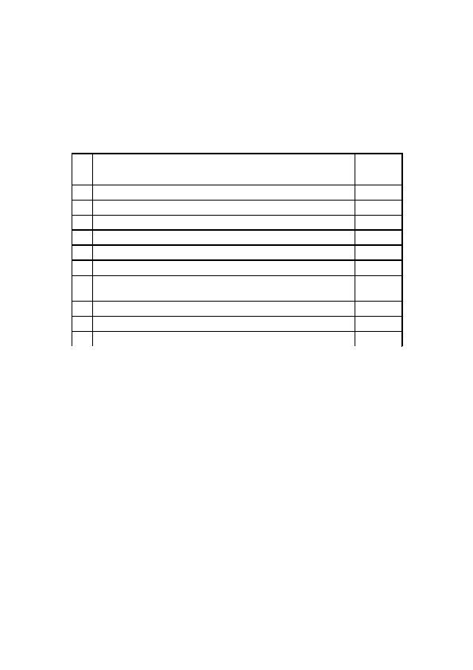
DIGITAL LOGIC DESIGN AND APPLICATIONS
Sr.
No
1
2
3
4
5
6
7

8
9
INDEX

Title of the Experiment
Study of BASIC Gates
Universal Gates
Study of Full & Half Adder & Subtractor using Gates
Study of Magnitude Comparator
Study of Multiplexer
Study of Demultiplexer
Implementation of Flip-Flops using NAND & Study of
7476
Study of Shift Register
Design of Counter & Study of IC 7490
10 Vo V/S Vi Characteristic of TTL & CMOS
Page
No.
3
6
8
10
11
13
15

17
19
21
2
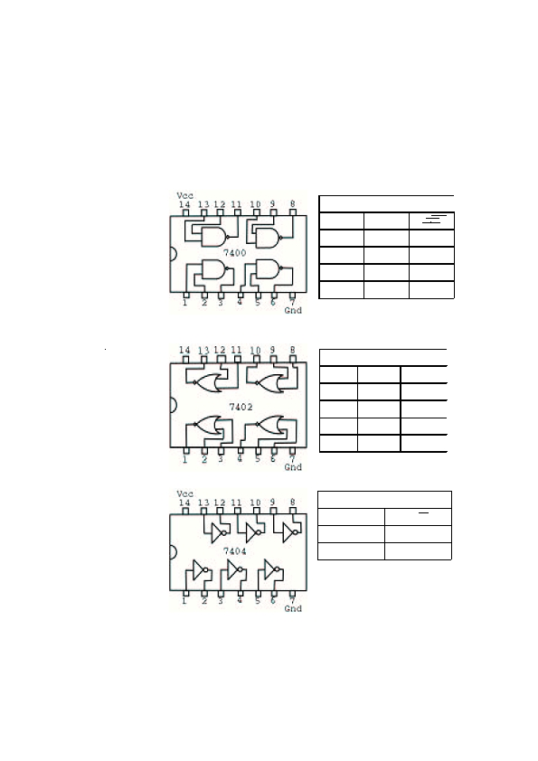
TITLE
AIM
APPARATUS
DIGITAL LOGIC DESIGN AND APPLICATIONS

EXPT. NO. 1
STUDY OF BASIC GATES
To study basic gates.
Power Supply, Breadboard, Connecting wires.
COMPONENTS ICs 7400, 7402, 7404, 7408, 7432, 7486, LED.
IC PINOUTS
TRUTH-TABLE

NAND
B
0
1
0
1
Y=A.B
1
1
1
0
A
0
0
1
1
A
0
0
1
1
NOR
B
0
1
0
1
Y=A+B
1
0
0
0
NOT
A
0
1
Y=A
1
0
3

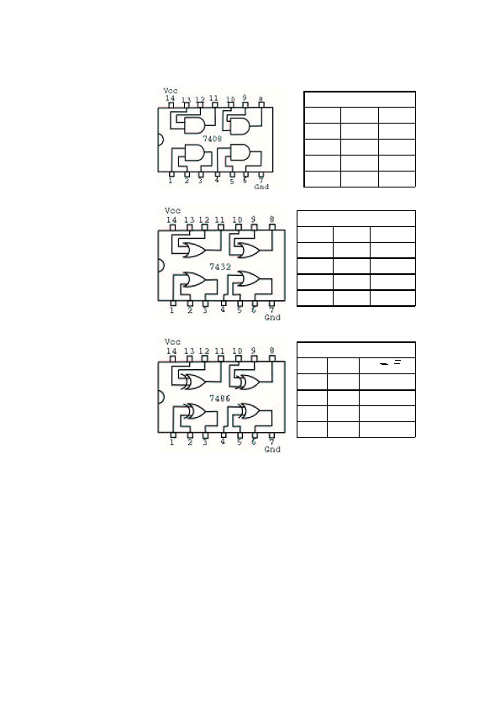
DIGITAL LOGIC DESIGN AND APPLICATIONS
A
0
0
1
1
AND
B
0
1
0
1
Y=A.B
0
0
0
1
A
0
0
1
1
OR
B
0
1
0
1
Y=A+B
0
1
1
1
EX-OR
B
0
1
0
1
Y=AB+AB
0
1
1
1
A
0
0
1
1
4


THEORY
DIGITAL LOGIC DESIGN AND APPLICATIONS

Logic gates are the digital circuits with one output and one or
more inputs. They are the basic building blocks of any logic ckt.
Different logic gates are : AND, OR, NOT, NAND, NOR, EX-
OR. They work according to certain logic.
AND : Logic eqn. Y = A.B
The output of AND gate is true when the inputs A and B are
True.
OR : Logic eqn. Y = A+B.
The output of OR gate is true when one of the inputs A and B or
both the inputs are true.
PROCEDURE
CONCLUSION
NOT : Logic eqn. Y = .
The output of NOT gate is complement of the input.
NAND : Logic eqn. Y = A.B
The output of NAND gate is true when one of the inputs or both
the inputs are low level.
NOR : Logical eqn. Y = A+B.
The output of NOR gate is true when both the inputs are low.
EX-OR: Logic eqn. Y=AB+AB.
The output of EX-OR gate is true when both the inputs are low.
1)Give biasing to the IC and do necessary connections.
2) Give various combinations of inputs and note down the output
with help of LED for all gate ICs one by one.
Thus all basic gates are studied.
5

su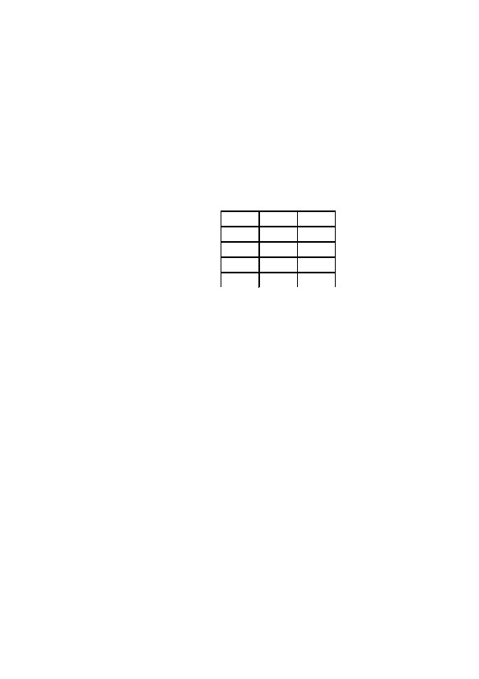
THEORY
DIGITAL LOGIC DESIGN AND APPLICATIONS

AND, OR, NOT are called basic gates as their logical operation
cannot be simplified further.
NAND and NOR are called universal gates as using only NAND
or only NOR any logic function can be implemented. Using
NAND and NOR gates and De Morgans Theorems different
basic gates & EX-OR gates are realized.
PROCEDURE
1)Give biasing to the IC and do necessary connections as shown
in the ckt. diagram.
2)Give various combinations of inputs and notedown output
using LED.
3) Repeat the procedure for all gates.
A
0
0
1
1
B
0
1
0
1
Y
OBSERVATION
TABLE
CONCLUSION
Thus universal gates are studied.
7

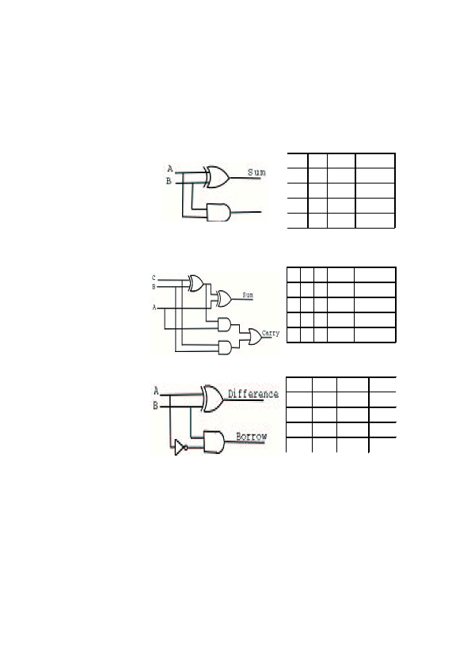
TITLE
AIM
APPARATUS
DIGITAL LOGIC DESIGN AND APPLICATIONS

EXPT. NO. 2
ADDER AND SUBTRACTOR
To study adder and subtractor circuits using logic gates.
Power supply, breadboard.
COMPONENTS ICs 7486, 7432, 7408, 7404, LEDs.
CIRCUIT
DIAGRAM
AND
OBSREVATION
TABLE
Half Adder
A
0
0
1
1
B Sum Carry
0
1
0
1
Full Adder
A B C Sum
Carry
Half Subtractor
A
B
Diff.
Bout
8

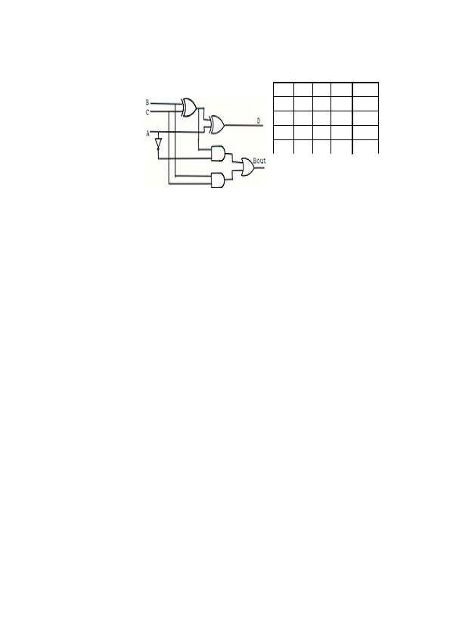
DIGITAL LOGIC DESIGN AND APPLICATIONS
Full Subtractor
A
B
C
D
Bout
THEORY
PROCEDURE
CONCLUSION
A digital adder circuit adds binary signals & a subtractor
subtracts binary signals. Half Adder/Subtractor is a basic ckt.
that adds / subtracts 2 bits and generates sum or difference along
with Carry / Borrow. Unlike half adder or subtractor a full adder
/ subtractor has the provision to take consideration of previous
carry / borrow also.
A digital adder circuit adds binary signals & a subtractor
subtracts binary signals. Half Adder / subtractor is a basic ckt.
that adds / subtracts 2 bits and generates sum or difference
along with Carry / Borrow. Unlike half adder or subtractor a full
adder / subtractor has the provision to take consideration of
previous carry / borrow also.
Thus half & full Adder / Subtractor is studied.
9

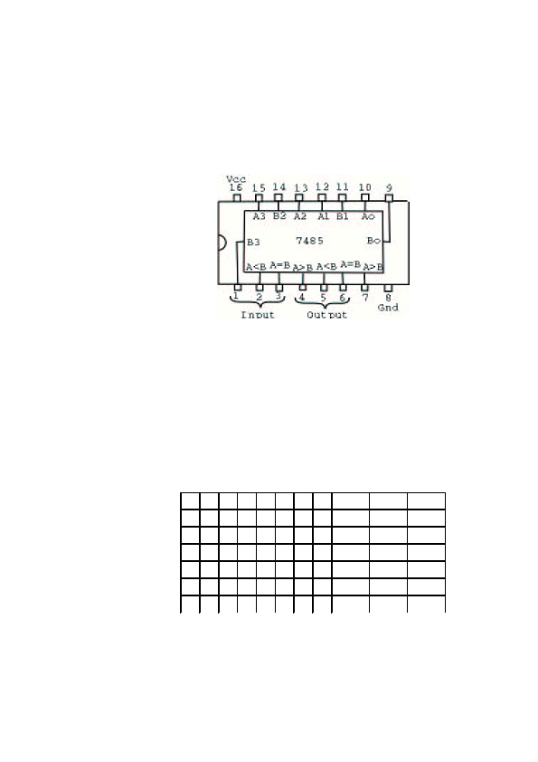
TITLE
AIM
APPARATUS
DIGITAL LOGIC DESIGN AND APPLICATIONS

EXPT. NO. 4
MAGNITUDE COMPARATOR
To study magnitude comparator.
Power supply, Breadboard.
COMPONENTS IC 7485, LEDs.
IC PINOUT
THEORY
PROCEDURE
OBSERVATION
TABLE
Magnitude Comparator compares two binary data signals A & B
and generates the results of comparision in form of three output
signals A>B, A=B, A<B. IC 7485 is a 4-bit comparator. The
cascade inputs A>B, A=B, A<B can be used to construct a
comparator comparing more than 4 bits. The compare outputs
depend on both compare i/ps as well as cascade i/ps.
1)Give biasing to the IC .
2)Give various two 4-bit inputs and note down output.
3)Do connections for cascading and note down output for
various two 8-bit inputs.
For 4-bit Comparator
A 3 A 2 A 1 A 0 B3
B2
B1
B0
A>B
A=B
A<B
CONCLUSION
Thus magnitude comparator is studied.
10

THEORY
PROCEDURE

C
St
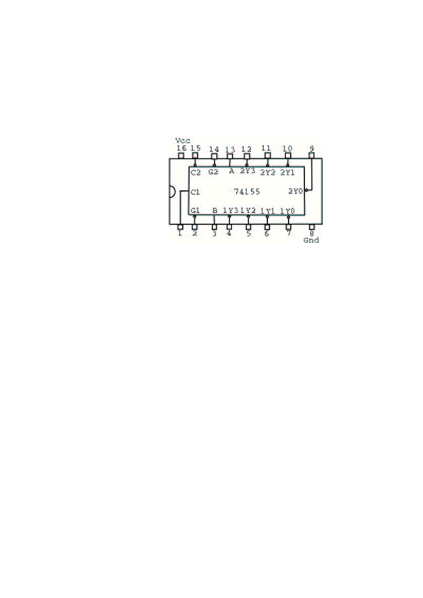
TITLE
AIM
APPARATUS
DIGITAL LOGIC DESIGN AND APPLICATIONS

EXPT. NO. 6
DEMULTIPLEXER
To study demultiplexer.
Power supply, Breadboard.
COMPONENTS IC 74155, LEDs.
IC PINOUT
THEORY
Demux takes single i/p & distributes it over several o/ps. It has
one data line, n o/p lines & m select lines where 2 = n.
The logic ckt. of 1:4 demux. using NAND gates is shown in the
dgm 1. The ckt. can also be used as binary to decimal decoder
with binary inputs applied at the select i/p lines & o/p will be
obtained on the corresponding line. MSI ICs available in TTL
family for demux. are 74138(3 line to 8 line decoder/demux.),
74139(dual 2 to 4 line decoder/driver.), 74154(4 to 16 line
decoder/demux), 74155(dual 2 to 4 line decoder) etc. IC 74155 is
a dual 2 to 4 line decoder. It has two sets of active low outputs
1Y0 to 1Y3 & 2Y0 to 2Y3. A & B are the select terminals
common for both the demux. C1, C2 & G1, G2 are the data lines
& strobe(enable) inputs for the two demux. C1 is active high, C2,
G1, G2 are active low. The two 2 line to 4 line demux. can be
combined to implement 3 line to 8 line demux.
1)Give biasing to the IC.
2)Do necessary connections.
m
PROCEDURE
13

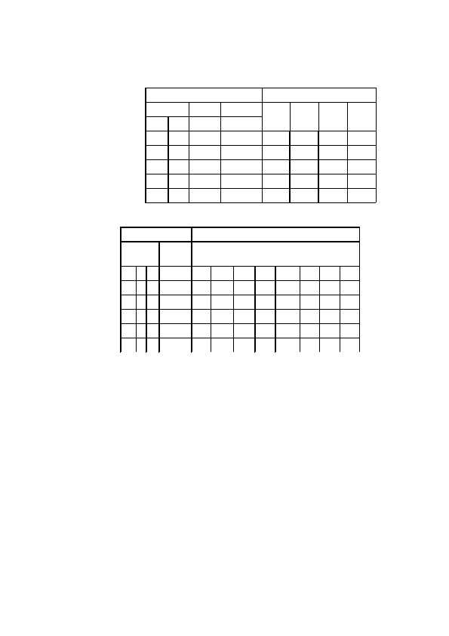
DIGITAL LOGIC DESIGN AND APPLICATIONS

OBSERVATION 2-Line to 4-Line Decoder OR 1-Line to 4-Line Demultiplexer
TABLE
Outputs
1Y1
1 2Y
1Y2
2 2Y
Select
B
Inputs
Strobe Data
1Y0
0 2Y
1Y3
3 2Y
A G 1/G2
C1/C2
3:8 Decoder OR 1:8 Demultiplexer
Inputs
Select

C B A
+
Strobe
(Data)
G‡
Outputs
2Y 0 2Y1
2Y2
2Y 3 1Y0
1Y 1 1Y 2 1Y3
C
+
= I/P's C 1 and C 2 connected together
G‡ = I/P's G 1 and G 2 connected together
CONCLUSION
ASSIGNMENT
Thus demultiplexer is studied.
1)Verify the operation of both the demux in IC 74155 as per the
truthtable.
2)Combine the two demux to give 3 line to 8 line demux &
verify
the operation.
14

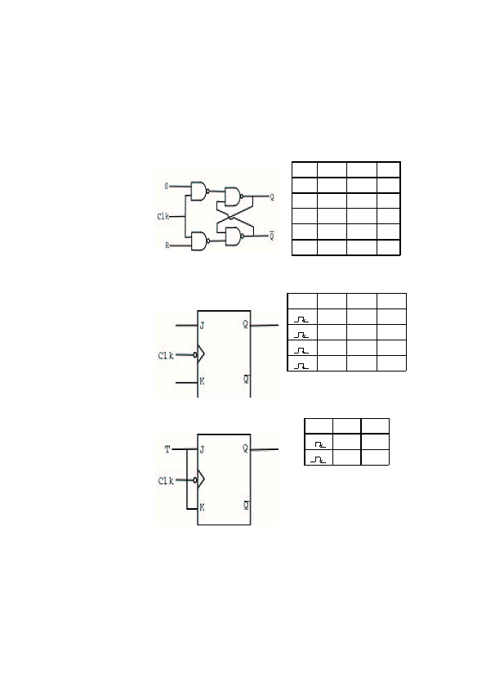
TITLE
AIM
APPARATUS
DIGITAL LOGIC DESIGN AND APPLICATIONS

EXPT. NO. 7
FLIP-FLOPS
To study R-S, J-K, D and T flip-flops using IC 7476.
Breadboard, Power supply.
COMPONENTS ICs 7400, 7402, 7476, LED.
CIRCUIT
DIAGRAM
AND
TRUTHTABLE
I) SR FF using NAND
Clk
0
1
1
1
1
S
X
0
0
1
1
R
X
0
1
0
1
Qn
II) JK FF (IC 7476)
Clk
Qn
1)
J
0
0
1
1
K
0
1
0
1
2) III) T FF using JK
Clk
T
0
1
Qn
3)
4)
15

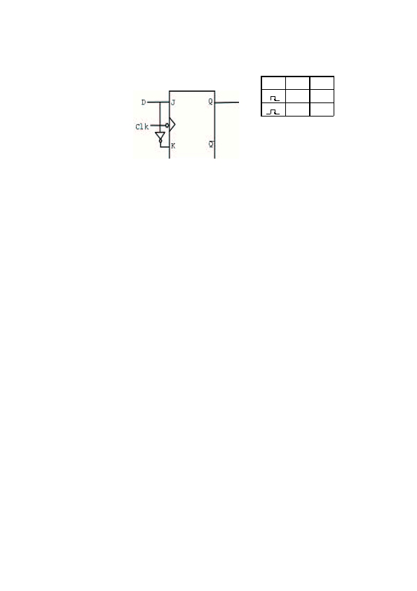
DIGITAL LOGIC DESIGN AND APPLICATIONS

5) IV) D FF using JK
Clk
6)
D
0
1
Qn
7)
THEORY
PROCEDURE

CONCLUSION
Flip-flops are the basic building blocks of sequential ckt. The
clocked FFs change their o/p state depending upon i/p's at
certain interval of time synchronized with the clock pulse
applied to it.
Different types of FFs are S-R, J-K, D & T . Their operations
are described by the respective truthtables. MSI chip 7476
incorporates two negative edge triggered Master-Slave JK
flipflops. The J-K flipflop can be converted to D & T flipflop.
1)Give biasing to the IC and do necessary connections.
2)For various combinations of i/p verify the truthtable.
Thus R-S, J-K, D & T Flip-Flops are studied.
ASSIGNMENTS 1)Construct clocked S-R FF using only NAND gates & verify
the truthtable.
2)Verify the truthtable of J-K FF using IC 7476. Observe the
effect of Preset & Clear i/ps.
3)Convert the J-K FF to D & T FF.
16

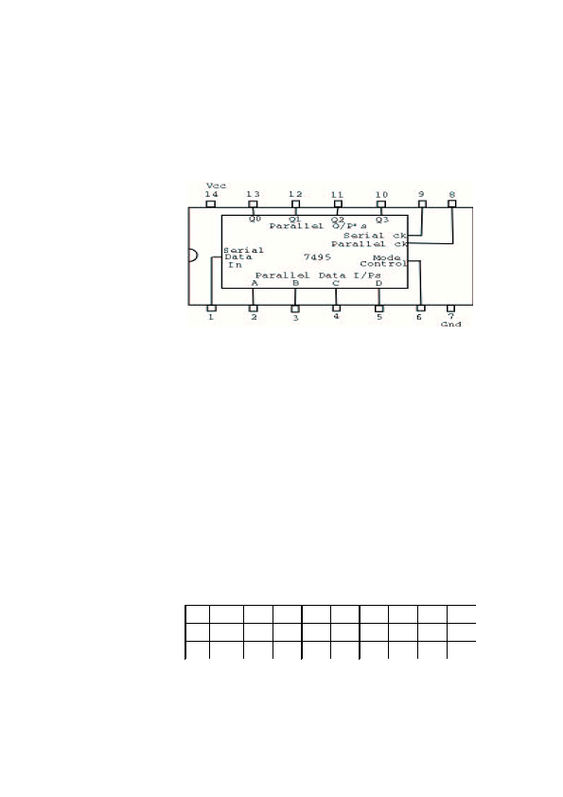
TITLE
AIM
APPARATUS
COMPONENTS
IC PINOUT
DIGITAL LOGIC DESIGN AND APPLICATIONS

EXPT. NO. 8
SHIFT REGISTER
To study shift registers.
Power supply, Breadboard.
IC 7495, LEDs.
THEORY
PROCEDURE
A flip-flop stores 1-bit of digital information. It is also referred
to as 1-bit register. An array of flip-flops is required to store
the no. of bits. This is called register. The data can be entered
into or retrieved from the register. So depending on the way
how the data can be entered or retrieved there are four possible
modes of operation.
1)Serial in serial out (SISO)
2)Serial in parallel out (SIPO)
3)Parallel in serial out (PISO)
4)Parallel in parallel out (PIPO)
Registers can be designed using J-K or S-R as D-type flip-flops
and are also available as MSI devices.
The register which can be operated in all possible modes & also
the shifting of data is possible in both the directions is called
Universal register.
1)Give biasing to the IC
2)Do connections for SIPO, PIPO & Left Shift and notedown
corresponding o/p.
OBSERVATIONS I) PIPO : Parallel I/P Parallel O/P
M
1
1
Clk2
0
A
X
B
X
C
X
D
X
QA
QB
QC
QD
17

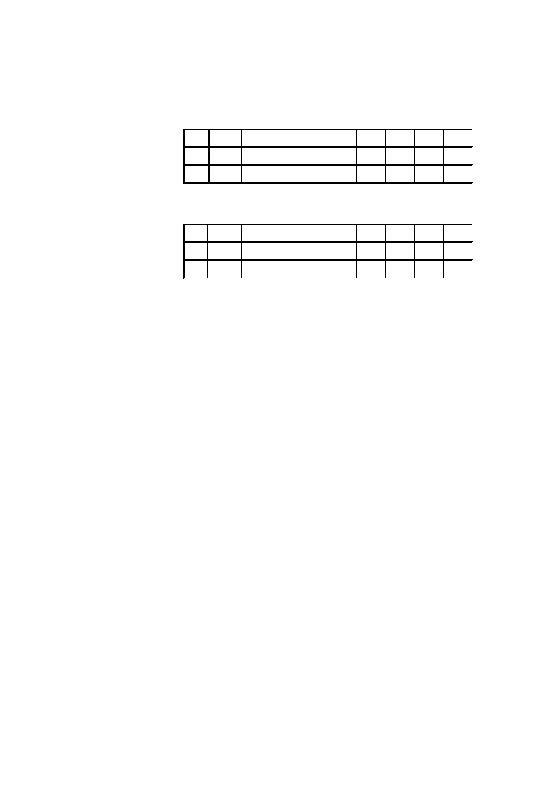
DIGITAL LOGIC DESIGN AND APPLICATIONS

II)SIPO : Serial I/P Parallel O/P
a) Shift Right
M
0
Clk1
Serial I / P
QA
QB
QC
QD
b) Shift Left
M
1
Clk2
D I / P
QA
QB
QC
QD
CONCLUSION
Thus shift register is studied.
18

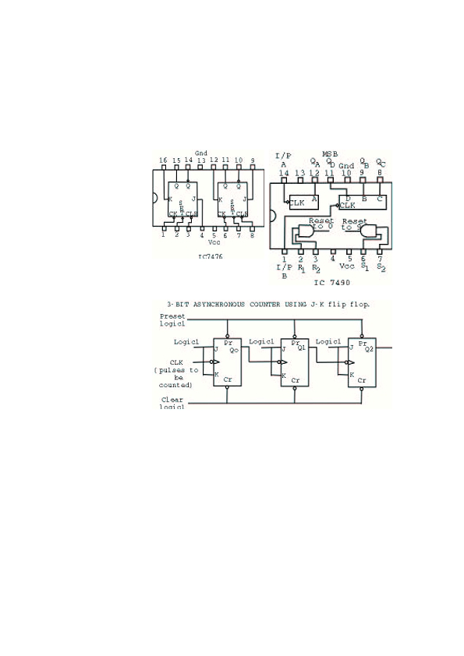
TITLE
AIM
APPARATUS
COMPONENTS
IC PINOUTS
DIGITAL LOGIC DESIGN AND APPLICATIONS

EXPT. NO. 9
COUNTERS
To study the counters.
Power supply, Breadboard.
ICs 7476, 7490, LEDs.
CIRCUIT
DIAGRAM
19

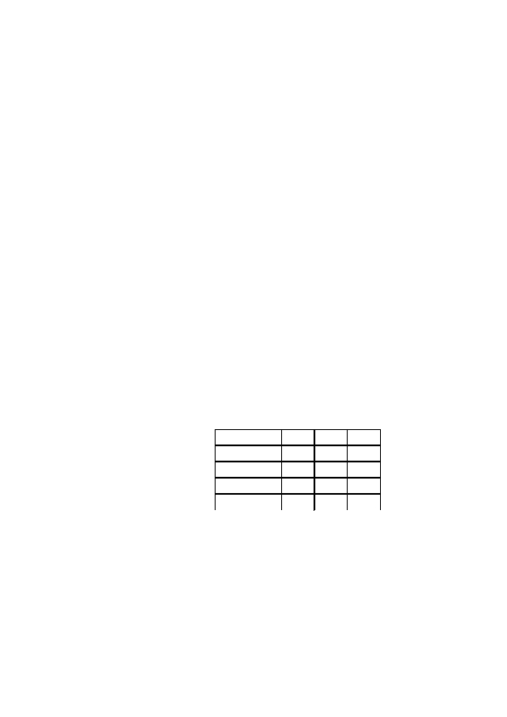
THEORY
DIGITAL LOGIC DESIGN AND APPLICATIONS

A ckt. used for counting the pulses is known as counter.
Basically there are two types of counters.
1)Asynchronous counter (ripple counter).
2)Synchronous counter.
Asynchronous counter :— In the case of an Asynchronous
Counter,all the flip-flops are not clocked simultaneously. This
counter is simple in operation & requires a min. of hardware.
But its speed is low. Each FF is triggered by a previous FF o/p.
Each FF takes its own time to give o/p (due to propagation
delay). So final settling time is high. They have the problem of
glitch.
Synchronous counter :— In synchronous counters all the Ffs
are clocked simultaneously. It is complex in construction, but
speed is more. In this case since each FF is clocked
simultaneously thus settling time is the delay time of single FF.
No problem of glitch.
Asynchronous counter IC (7490) :— It is a BCD counter. It
consists of four FFs internally connected to provide a mod-2
counter and a mod-5 counter. The mod-2 and mod-5 counters
can be used independently or in combination. FFA operates as
a mod2 counter whereas the combination of FFB, FFC and
FFD form a mod-5 counter. There are two reset inputs R1 &
R2 both of which are to be connected to logic 1 level for
clearing all the FFs. The two set inputs S1 & S2 when
connected to logic1 level are used for setting the counter to
1001.
PROCEDURE
1)Do connections as per the ckt. dgm.
2)Give biasing to the ICs.
3)Observe o/p using LEDs.
Counter State
0
:
:
7
Q0
OBSERVATIONS
Q1
Q2
CONCLUSION
Thus counters is studied.
20

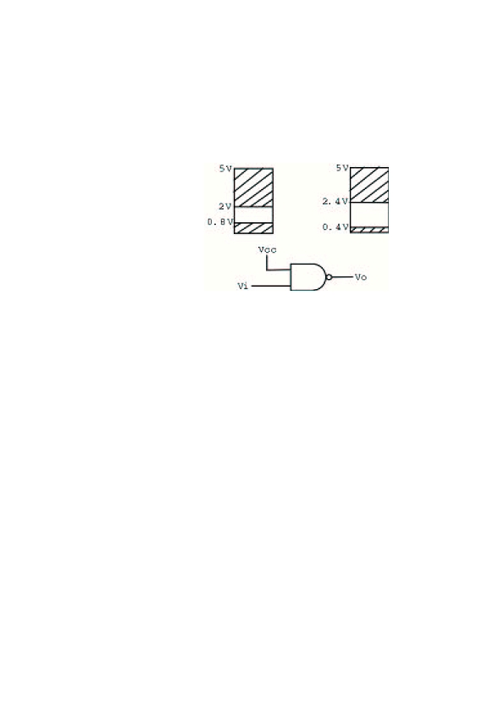
TITLE
AIM
APPARATUS
COMPONENTS
CIRCUIT
DIAGRAM
DIGITAL LOGIC DESIGN AND APPLICATIONS

EXPT. NO. 10
TRANSFER CHARACTERISTIC OF TTL AND CMOS
To study TTL & CMOS transfer characteristics.
Dual Power supply, Breadboard, Multimeter.
ICs 74LS00, 74HC00.
THEORY
A group of compatible ICs with the same logic levels and
supply voltages for performing various logic functions have
been fabricated using a specific ckt. configuration which is
referred to as a logic family. TTL (Transistor-Transistor logic)
is one of the saturated Bipolar logic families. CMOS
(Complementary metal oxide semiconductor) is an unipolar
logic family. Various chars. of digital ICs are used to compare
their performances.
Current & Voltage parameters :-
High level i/p voltage V IH :— This is the min. i/p voltage at
the o/p corresponding to logic1.
Low level i/p voltage V IL :— This is the max. i/p voltage
which is recognized by the gate as logic0.
High level output voltage VOH :— This is the min. voltage
available at the o/p corresponding to logic1.
Low level o/p voltage VOL :— This is the max. voltage
available at the o/p corresponding to logic0.
1)Connect the ckt. as per ckt. dgm. for TTL IC.
2)Vary the i/p voltage in steps & notedown corresponding o/p
voltage.
3)Plot graph of Vi Vs Vo.
4)Repeat same procedure for CMOS IC.
PROCEDURE
21


DIGITAL LOGIC DESIGN AND APPLICATIONS
OBSERVATIONS
Vi
Vo
CONCLUSION
Thus transfer characteristics of TTL & CMOS ICs is studied.
22

